MATPLOTLIB (PLOTTING LIBRARY)

AIM:
To visualize the relationship between study hours and exam scores using different plots such as Scatter Plot, Line Plot, Histogram, and Bar Chart in Python using Matplotlib.

ALGORITHM:
- Import the Pandas, Matplotlib, and NumPy libraries.
- Create a dataset containing study hours and exam scores.
- Convert the dataset into a Pandas DataFrame.
- Draw a Scatter Plot to show the relationship between study hours and exam scores.
- Draw a Line Plot to display the progress of exam scores as study hours increase.
- Draw a Histogram to show the distribution of exam scores.
- Draw a Bar Chart to compare study hours and exam scores.
- Add appropriate labels and titles to each plot.
- Display all the plots using plt.show().
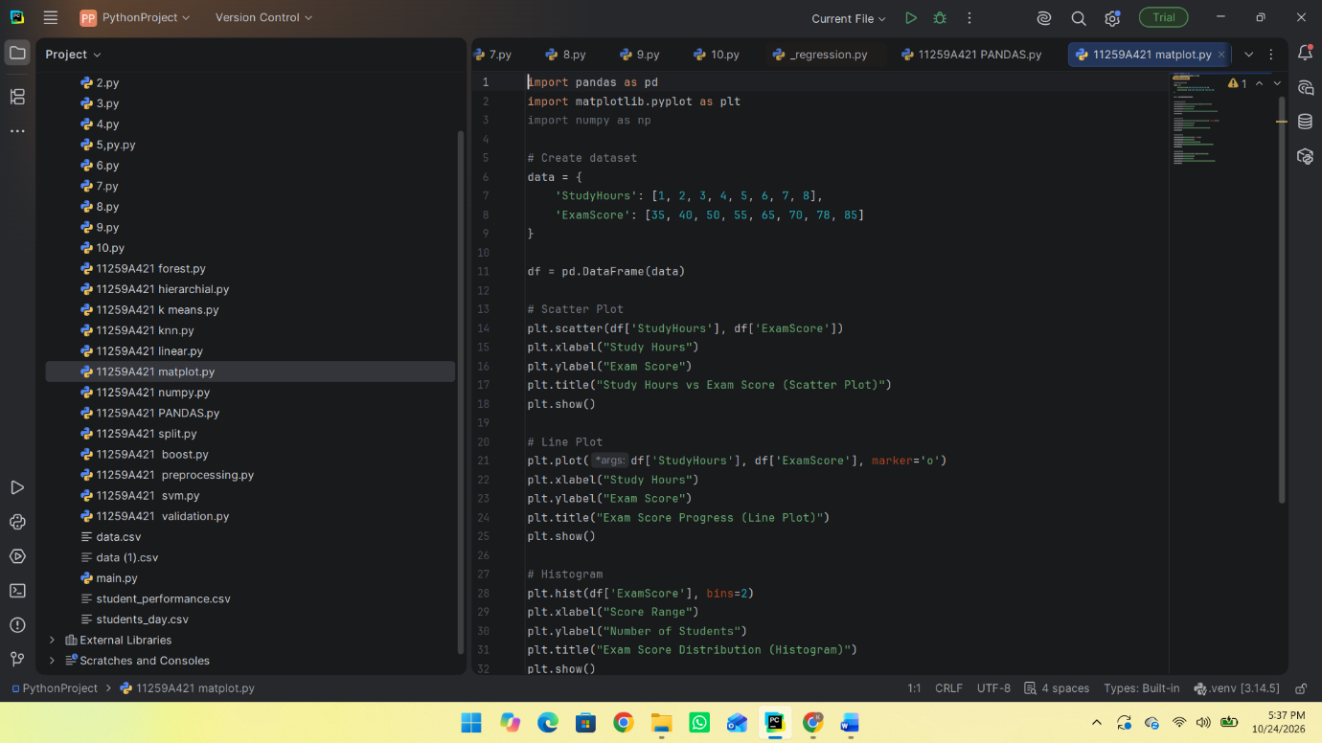
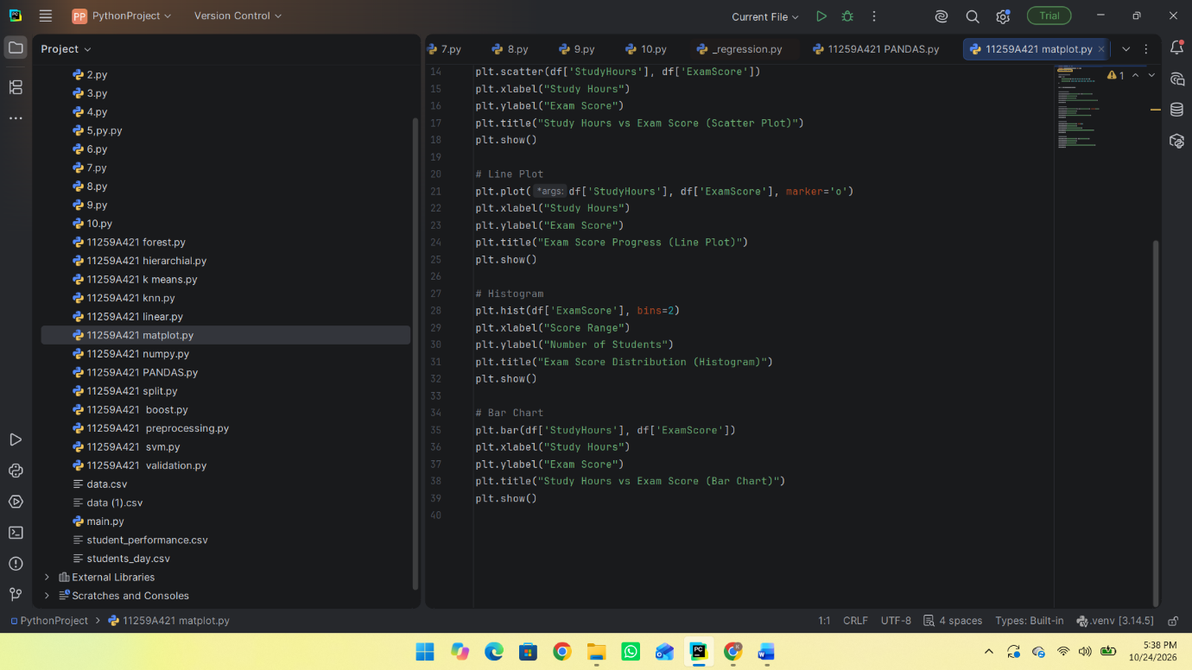
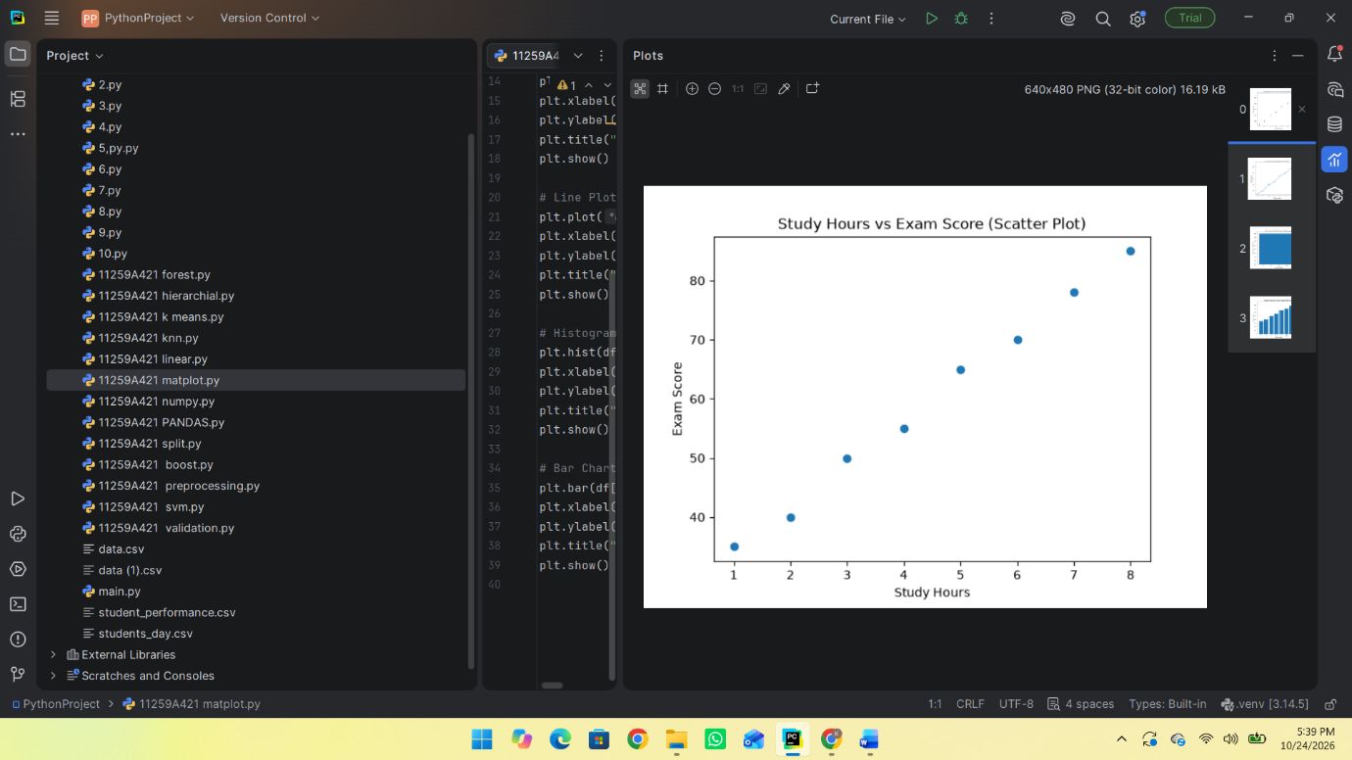
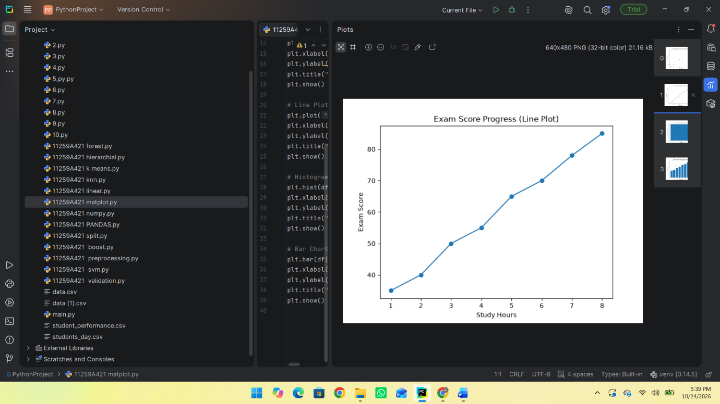
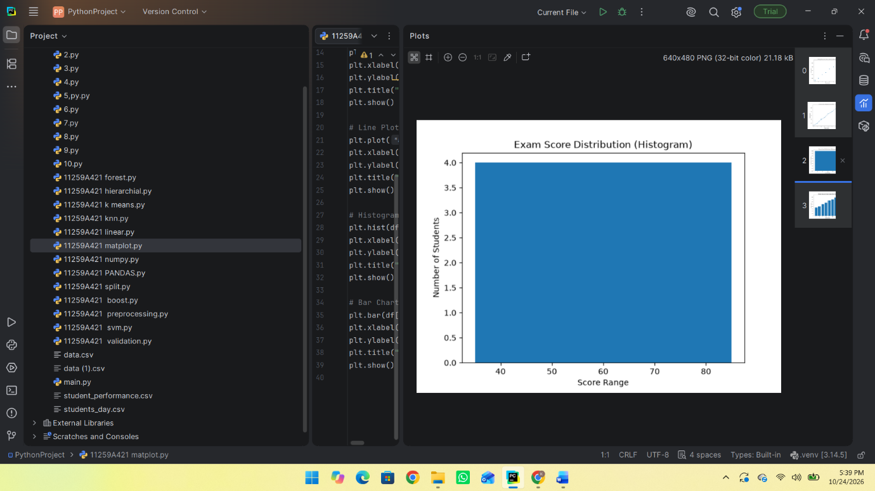
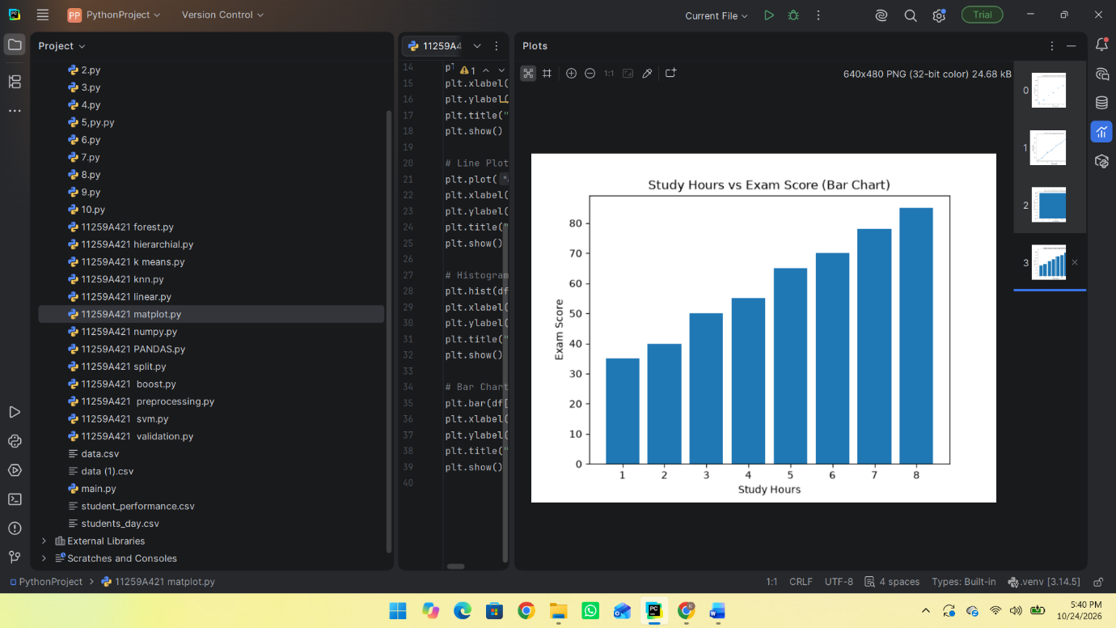

RESULT:
Thus, the dataset was successfully visualized using Scatter Plot, Line Plot, Histogram, and Bar Chart in Python. The graphs show that exam scores generally increase as study hours increase.

